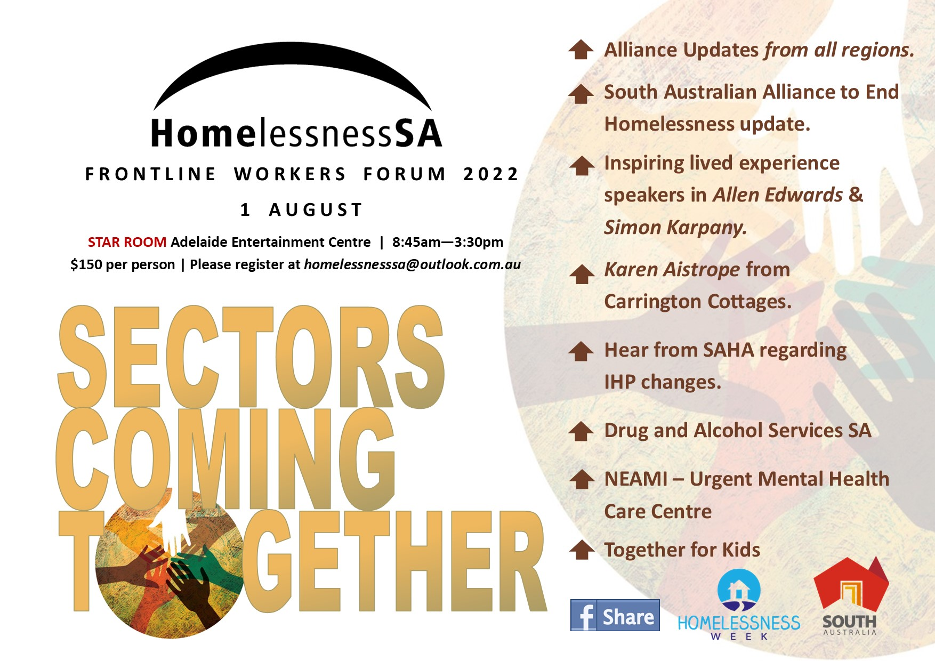

HURRY
NEARLY SOLD OUT

Frontline Workers Forum 2022
Registration Form
Proudly Sponsored By

- Alliance Updates from all regions
- South Australian Alliance to End Homelessness (SAAEH) update
- Inspiring Lived Experience speakers in Allen Edwards and Simon Karpany
- Karen Aistrope from Carrington Cottages
- SAHA update us about the IHP changes
- Together for Kids – the children’s voice
- Drug and Alcohol Services SA explain how they can support people experiencing homelessness in the inner city
- NEAMI – Urgent Mental Health Care Centre
1st August 2022
Please complete and return the registration form to Homelessness SA by Friday the 22nd of July 2022 to homelessnesssa@outlook.com.au For phone enquiries phone Tania - Ph: 8110 8539 or 0419 839 671
Cost is $150 per person, please advise who you would like to be invoiced
Attendee Name: __________________________________Position: _________________________
Homelessness Sector Specifics (Youth, Generic, Domestic Violence): _________________________
Email and Phone: __________________________________________________________________
Special Dietary Requirements: ________________________________________________________
Name and email address to send the invoice to___________________________________________
Are you happy for your email and organisational details to be shared with other participants to assist with developing contacts and networking YES ○ NO ○
Morning tea and Networking lunch provided
Where: Entertainment Centre (enter via main entrance) The forum will be held in the Star Room
When: 1 August 2022 8:45 am registration for 9am start (8:45am to 3/3:30pm)
Parking is complimentary via Gate 1 off Port Road which is located near the Star Room. Parking is underground near the Star Room - Map provided upon registration. We will be taking photos at the event which will be displayed on our Facebook Page

